**STUDENT NAME: SEJAL SANTOSH BHEKARE**

**LIFELINE**

**BLOOD BANK** **DATABASE**

**MANAGEMENT SYSTEM**





**THE AIM OF A PROJECT on blood bank database management is to create a comprehensive and efficient system that manages the storage, retrieval, and dissemination of information related to blood donations, inventory, donors, recipients, and other relevant data within a blood bank or blood donation center. Here are some specific objectives or goals that such a project might aim to achieve:**

**Efficient Blood Inventory Management:** Develop a system that tracks the inventory of different blood types, quantities available, expiration dates, and storage conditions to ensure an adequate supply of blood at all times.

**Donor Information Management:** Create a database to store information about blood donors, including personal details, medical history, donation frequency, and contact information.

**Recipient Matching:** Implement a system that matches blood donors with recipients based on compatibility of blood types and other medical criteria.

**Security and Access Control:** Ensure data security and implement access controls to protect sensitive donor and patient information in compliance with privacy regulations

**User-Friendly Interface:** Design an intuitive and user-friendly interface for both donors and blood bank staff to easily input and retrieve information.

**User-Friendly Interface:** Design an intuitive and user-friendly interface for both donors and blood bank staff to easily input and retrieve information

By achieving these aims, the project aims to streamline the operations of the blood bank, enhance the efficiency of blood donation processes, improve donor and recipient experiences, and ultimately contribute to saving lives by maintaining a steady and accessible blood supply for those in need.

ER DIAGRAM

**RECEIVER**

**receiver_id,**

**receiver_name,**

**gender,**

**age,**

**address,**

**state,**

**blood_group,**

**b_id,**

**contactno,**

**receiveing_date**

RECEIVE BY

DONATE

**BY**

**BLOOD TYPE**

**Blood_id,**

**Blood_type**

**DONAR**

**donar_id**

**donar_name,**

**gender,**

**age,**

**contactno,**

**blood_group,**

**address,**

**state,**

**date_0f_donate**

**TABLE DESCRIPTION:**

**Blood type:**

+------------+-------------+------+-----+---------+-------+

| Field | Type | Null | Key | Default | Extra |

+------------+-------------+------+-----+---------+-------+

| blood_id | int(11) | NO | PRI | NULL | |

| blood_type | char(5) | NO | | NULL | |

+------------+-------------+------+-----+---------+-------+

**Receiver:**

+----------------+--------------+------+-----+---------+-------+

| Field | Type | Null | Key | Default | Extra |

+----------------+--------------+------+-----+---------+-------+

| receiver_id | int | NO | PRI | NULL | |

| receiver_name | varchar(20) | NO | | NULL | |

| gender | char(10) | YES | | NULL | |

| age | int | YES | | NULL | |

| address | varchar(30) | YES | | NULL | |

| state | varchar(15) | YES | | NULL | |

| blood_group | char(5) | YES | | NULL | |

| b_id | int | YES | MUL | NULL | |

| contactno | bigint(10) | YES | | NULL | |

| receiving_date | date | YES | | NULL | |

+----------------+--------------+------+-----+---------+-------+

**Donar:**

+---------------+--------------+------+-----+---------+-------+

| Field | Type | Null | Key | Default | Extra |

+---------------+--------------+------+-----+---------+-------+

| donar_id | int(11) | NO | PRI | NULL | |

| donar_name | varchar(20) | NO | | NULL | |

| gender | char(10) | YES | | NULL | |

| age | int(11) | YES | | NULL | |

| contactno | bigint(10) | YES | | NULL | |

| blood_group | char(10) | YES | | NULL | |

| address | varchar(30) | YES | | NULL | |

| state | varchar(15) | YES | | NULL | |

| date_0f_donate| date | YES | | NULL | |

+---------------+--------------+------+-----+---------+-------+

**COMMANDS TO CREATE TABLES:**

**Create database:**

create database lifeline_bloodbank;

use lifeline_bloodbank;

**create table bloodtype:**

**create** **table** bloodtype (

blood_id **int** **primary key**,

blood_type **char(5) not null**);

**desc** bloodtype;

**create table donar:**

**create table** donar(

donar_id **int primary key**,

donar_name **varchar(20) not null**,

gender **char(10),**

age **int**,

contactno **bigint(10)**,

blood_group **char(10),**

address **varchar(30),**

state **varchar(15)**,

date_0f_donate **date);**

**desc** donar;

**create table receiver:**

**create table** receiver(

receiver_id **int primary key**,

receiver_name **varchar(20) not null,**

gender **char(10),**

age **int**,

address **varchar(30),**

state **varchar(15),**

blood_group **char(5)**,

b_id **int**,

**constraint fk_b_id foreign key (b_id) REFERENCES bloodtype(blood_id)**

**on delete cascade**

**on update cascade,**

contactno **bigint(10),**

receiveing_date **date);**

**desc** receiver;

**show tables;**

**COMMANDS TO INSERT VALUES IN TABLE**

**Table bloodtype:**

insert into bloodtype values

(101, "A+"),

(102, "A-"),

(103, "B+"),

(104, "B-"),

(105, "AB+"),

(106, "AB-"),

(107, "O+"),

(108, "O-");

**select * from bloodtype**;

**Table donar:**

INSERT INTO donar VALUES

('107A', 'John Doe', 'Male', 30, 1234567890, 'O+', '123 Main St', 'karnataka', '2023-01-01'),

('102B', 'Jane Smith', 'Female', 25, 9876543210, 'A-', '456 Elm St', 'new delhi', '2023-02-02'),

('103C', 'David Johnson', 'Male', 40, 5551112222, 'B+', '789 Oak St', 'uttarpradesh', '2023-03-03'),

('106D', 'Sarah Williams', 'Female', 35, 9998887777, 'AB-', '101 Pine St', 'new delhi', '2023-04-04'),

('108E', 'Michael Brown', 'Male', 28, 3332221111, 'O-', '246 Maple St', 'maharashtra', '2023-05-05'),

('101F', 'Emily Davis', 'Female', 22, 7778889999, 'A+', '369 Cedar St', 'goa', '2023-06-06'),

('105G', 'William Miller', 'Male', 32, 1112223334, 'AB+', '808 Walnut St', 'maharashtra', '2023-07-07'),

('104H', 'Olivia Wilson', 'Female', 27, 4445556667, 'B-', '707 Cherry St', 'tamilnadu', '2023-08-08'),

('107I', 'Ethan Moore', 'Male', 31, 8889990001, 'O+', '505 Birch St', 'goa', '2023-09-09'),

('102J', 'Sophia Taylor', 'Female', 29, 6667778882, 'A-', '919 Pineapple St', 'new delhi', '2023-10-10'),

('106K', 'Noah Anderson', 'Male', 33, 1212121212, 'AB-', '112 Orange St', 'maharashtra', '2023-11-11'),

('103L', 'Ava Thomas', 'Female', 26, 3434343434, 'B+', '567 Lemon St', 'maharashtra', '2023-12-12'),

('108M', 'Liam Jackson', 'Male', 24, 5656565656, 'O-', '131 Strawberry St', 'new delhi', '2024-01-01'),

('101N', 'Emma White', 'Female', 30, 7878787878, 'A+', '848 Grape St', 'goa', '2024-02-02'),

('104O', 'James Harris', 'Male', 36, 9090909090, 'B-', '909 Cherry St', 'karnataka', '2024-03-03'),

('105P', 'Mia Martin', 'Female', 23, 2323232323, 'AB+', '232 Plum St', 'uttarpradesh', '2024-04-04'),

('107Q', 'Benjamin Garcia', 'Male', 37, 5454545454, 'O+', '545 Banana St', 'uttarpradesh', '2024-05-05'),

('102R', 'Charlotte Martinez', 'Female', 21, 6767676767, 'A-', '676 Orange St', 'maharashtra', '2024-06-06'),

('103S', 'Elijah Robinson', 'Male', 38, 7878787878, 'B+', '878 Pineapple St', 'maharashtra', '2024-07-07'),

('108T', 'Amelia Clark', 'Female', 20, 9090909090, 'O-', '909 Lime St', 'tamilnadu', '2024-08-08'),

('106U', 'Lucas Rodriguez', 'Male', 39, 2323232323, 'AB-', '232 Lemon St', 'hariyana', '2024-09-09'),

('101V', 'Avery Adams', 'Female', 19, 5454545454, 'A+', '545 Apple St', 'punjab', '2024-10-10'),

('104W', 'Harper Campbell', 'Male', 40, 6767676767, 'B-', '676 Grape St', 'tamilnadu', '2024-11-11'),

('107X', 'Logan Hill', 'Female', 18, 7878787878, 'O+', '878 Banana St', 'maharashtra', '2024-12-12'),

('102Y', 'Aria Ward', 'Male', 41, 9090909090, 'A-', '909 Grapefruit St', 'tamilnadu', '2025-01-01'),

('108Z', 'Grace Sullivan', 'Male', 42, 5454545454, 'O-', '545 Mango St', 'hariyana', '2025-03-03'),

('105AA', 'Henry Powell', 'Female', 16, 6767676767, 'AB+', '676 Pine St', 'rajasthan', '2025-04-04'),

('101AB', 'Stella Long', 'Male', 43, 7878787878, 'A+', '878 Peach St', 'rajasthan', '2025-05-05'),

('104AC', 'Wyatt Hughes', 'Female', 15, 9090909090, 'B-', '909 Pear St', 'rajasthan', '2025-06-06'),

('105AD', 'sejal bhekare', 'female', 21, 7400220393, 'AB+', '228 riva rthyem', 'maharashtra', '2002-09-28');

**select * from donar;**

**Table Receiver:**

INSERT INTO receiver VALUES

(101, 'John Doe', 'Male', 25, '123 Main St', 'maharashtra', 'AB+',105 , 1234567890, '2023-01-15'),

(102, 'Jane Smith', 'Female', 30, '456 Elm St', 'karnatka','O-', 108, 9876543210, '2023-02-20'),

(103, 'David Johnson', 'Male', 40, '789 Oak St','new delhi', 'A+', 101, 5555555555, '2023-03-10'),

(104, 'Emily Williams', 'Female', 22, '321 Pine St', 'maharashtra','B-', 104, 1111111111, '2023-04-05'),

(105, 'Michael Brown', 'Male', 35, '654 Maple St', 'punjab','O+', 107, 9999999999, '2023-05-12'),

(106, 'Sophia Garcia', 'Female', 28, '987 Cedar St','goa', 'AB-', 106, 7777777777, '2023-06-25'),

(107, 'William Martinez', 'Male', 45, '741 Birch St', 'tamilnadu','A-', 102, 3333333333, '2023-07-18'),

(108, 'Olivia Jones', 'Female', 20, '852 Walnut St', 'maharashtra','B+', 103, 8888888888, '2023-08-30'),

(109, 'Daniel Miller', 'Male', 29, '159 Cherry St', 'rajasthan','AB+', 105, 4444444444, '2023-09-22'),

(110, 'Ava Wilson', 'Female', 32, '369 Spruce St', 'rajasthan','O-', 108, 6666666666, '2023-10-05'),

(111, 'Ethan Davis', 'Male', 27, '753 Ash St', 'new delhi','A+', 101, 2222222222, '2023-11-14'),

(112, 'Chloe Rodriguez', 'Female', 33, '852 Pineapple St','new delhi', 'B-', 104, 5556667777, '2023-12-28'),

(113, 'Alexander Lee', 'Male', 26, '963 Mango St','punjab', 'O+', 107, 1231231234, '2024-01-02'),

(114, 'Madison Campbell', 'Female', 24, '147 Orange St','punjab', 'AB-', 105, 9876543210, '2024-02-15'),

(115, 'Noah Hernandez', 'Male', 31, '258 Banana St','uttarpradesh', 'A-', 102, 9871236540, '2024-03-20'),

(116, 'Avery Torres', 'Female', 29, '369 Grape St', 'uttarpradesh','B+', 103, 1112223334, '2024-04-12'),

(117, 'Mia Gonzales', 'Female', 23, '753 Lemon St', 'uttarpradesh','AB+', 105, 3334445556, '2024-05-05'),

(118, 'Liam Perez', 'Male', 36, '852 Lime St','maharashtr', 'O-', 108, 9876543210, '2024-06-18'),

(119, 'Harper Nguyen', 'Female', 30, '963 Apple St','maharashtra','A+', 101, 9876543210, '2024-07-30'),

(120, 'Evelyn Kim', 'Female', 28, '147 Avocado St','maharashtra', 'B-', 104, 9876543210, '2024-08-22'),

(121, 'James Patel', 'Male', 41, '258 Papaya St','maharashtra', 'O+', 107, 9876543210, '2024-09-05'),

(122, 'Grace Khan', 'Female', 26, '369 Guava St','tamilnadu', 'AB-', 106, 9876543210, '2024-10-14'),

(123, 'Benjamin Singh', 'Male', 34, '753 Pomegranate St', 'tamilnadu', 'A-', 102, 9876543210, '2024-11-28'),

(124, 'Aria Kumar', 'Female', 25, '852 Watermelon St','tamilnadu','B+', 103, 9876543210, '2024-12-02'),

(125, 'Logan Das', 'Male', 29, '963 Kiwi St','goa', 'AB+', 105, 9876543210, '2025-01-15'),

(126, 'Luna Joshi', 'Female', 27, '147 Pineapple St', 'goa','O-', 108, 9876543210, '2025-02-20'),

(127, 'Henry Li', 'Male', 37, '258 Orange St','goa', 'A+', 101, 9876543210, '2025-03-10'),

(128, 'Zoe Chen', 'Female', 22, '369 Banana St','hariyana', 'B-', 104, 9876543210, '2025-04-05'),

(129, 'Mason Wu', 'Male', 33, '753 Grape St', 'hariyana','O+', 107, 9876543210, '2025-05-12'),

(130, 'Ellie Gupta', 'Female', 31, '852 Lemon St', 'hariyana','AB-', 106, 9876543210, '2025-06-25');

select * from receiver;

#Find the total count of receivers in each state:

SELECT state, COUNT(*) AS count FROM receiver GROUP BY state;

|  |  |
| --- | --- |
| state | Total count |
| goa | 4 |
| hariyana | 3 |
| karnatka | 1 |
| maharashtr | 1 |
| maharashtra | 6 |
| new delhi | 3 |
| punjab | 3 |
| rajasthan | 2 |
| tamilnadu | 4 |
| uttarpradesh | 3 |

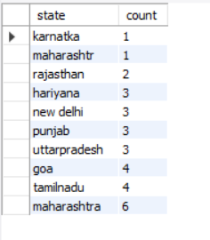

#Count the number of donors in each blood group:

SELECT blood_group, COUNT(*) AS count FROM donar GROUP BY blood_group;

|  |  |
| --- | --- |
| Blood_group | Total count |
| A+ | 4 |
| A- | 4 |
| AB+ | 4 |
| AB- | 3 |
| B+ | 3 |
| B- | 4 |
| O+ | 4 |
| O- | 4 |

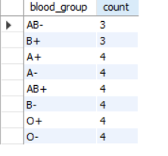

#List donors who donated in 2023 and are from Maharashtra:

SELECT donar_name, contactno,blood_group, state, date_0f_donate FROM donar WHERE YEAR(date_0f_donate) = 2023 AND state = 'maharashtra';

|  |  |  |  |  |
| --- | --- | --- | --- | --- |
| Donar_name | Contact no | Blood group | state | Date of donate |
| Ava Thomas | 3434343434 | B+ | maharashtra | 2023-12-12 | |
| William Miller | 1112223334 | AB+ | maharashtra | 2023-07-07 | |
| Noah Anderson | 1212121212 | AB- | maharashtra | 2023-11-11 | |
| Michael Brown | 3332221111 | O- | maharashtra | 2023-05-05 | |

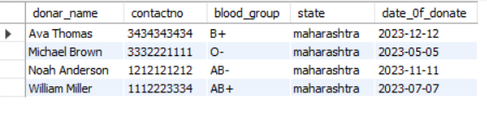

**#Get male donors older than 30:**

**SELECT donar_name, age, gender FROM donar WHERE gender = 'Male' AND age > 30;**

|  |  |  |
| --- | --- | --- |
| **Donar name** | **age** | **gender** |
| Stella Long | 43 | Male |
| Aria Ward | 41 | Male |
| David Johnson | 40 | Male |
| Elijah Robinson | 38 | Male |
| James Harris | 36 | Male |
| Harper Campbell | 40 | Male |
| William Miller | 32 | Male |
| Noah Anderson | 33 | Male |
| Lucas Rodriguez | 39 | Male |
| Ethan Moore | 31 | Male |
| Benjamin Garcia | 37 | Male |
| Grace Sullivan | 42 | Male |

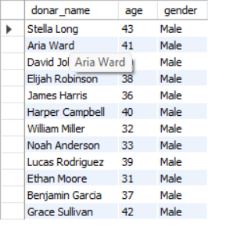

#Retrieve donors who have the same blood type as a specific receiver:

SELECT * FROM donar WHERE blood_group =

(SELECT blood_group FROM receiver WHERE receiver_id = 101);

|  |  |  |  |  |  |  |  |  |
| --- | --- | --- | --- | --- | --- | --- | --- | --- |
| Donar ID | Donar name | gender | age | Contact no | Blood group | address | state | Date of donate |
| 105AA | Henry Powell | Female | 16 | 6767676767 | AB+ | 676 Pine St | rajasthan | 2025-04-04 |
| 105AD | sejal bhekare | female | 21 | 7400220393 | AB+ | 228 riva rthyem | maharashtra | 2002-09-28 |
| 105G | William Miller | Male | 32 | 1112223334 | AB+ | 808 Walnut St | maharashtra | 2023-07-07 |
| 105P | Mia Martin | Female | 23 | 2323232323 | AB+ | 232 Plum St | uttarpradesh | 2024-04-04 |
|  |  |  |  |  |  |  |  |  |

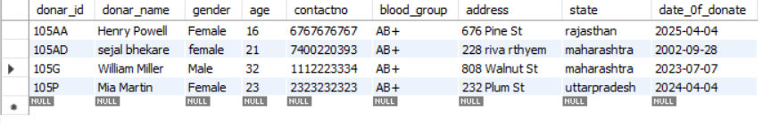

#Retrieve the names of receivers along with their respective donor names to receivers who want to received blood from donors in the same state.



SELECT receiver.receiver_name, donar.donar_name, donar.state, donar.contactno

FROM receiver

LEFT JOIN donar ON receiver.b_id = donar.donar_id

WHERE receiver.state = donar.state;

|  |  |  |  |
| --- | --- | --- | --- |
| Receiver_name | Donar_name | contactno | state |
| William Martinez | Aria Ward | 9090909090 | goa |
| Olivia Jones | Ava Thomas | 3434343434 | goa |
| Olivia Jones | Elijah Robinson | 7878787878 | tamilnadu |
| Mia Gonzales | Mia Martin | 2323232323 | tamilnadu |
| John Doe | sejal bhekare | 7400220393 | uttarpradesh |
| John Doe | William Miller | 1112223334 | maharashtra |
| James Patel | Logan Hill | 7878787878 | maharashtra |
| Henry Li | Emily Davis | 7778889999 | rajasthan |
| Henry Li | Emma White | 7878787878 | maharashtra |
| Ellie Gupta | Lucas Rodriguez | 2323232323 | maharashtra |
| Daniel Miller | Henry Powell | 6767676767 | uttarpradesh |
| Benjamin Singh | Aria Ward | 9090909090 | hariyana |
| Avery Torres | David Johnson | 7878787878 | maharashtra |

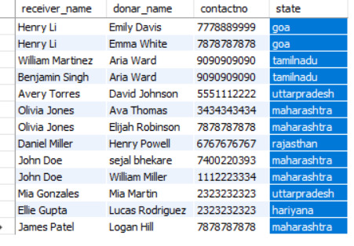

#Selecting receivers and their respective blood types from a specific state:

SELECT receiver.receiver_name, bloodtype.blood_type, receiver.state, bloodtype.blood_id

FROM receiver

INNER JOIN bloodtype ON receiver.b_id = bloodtype.blood_id

WHERE receiver.state = 'maharashtra';

|  |  |  |  |
| --- | --- | --- | --- |
| Receiver_name | Blood_type | state | Blood_id |
| Harper Nguyen | A+ | maharashtra | 101 |
| Olivia Jones | B+ | maharashtra | 103 |
| Emily Williams | B- | maharashtra | 104 |
| Evelyn Kim | B- | maharashtra | 104 |
| John Doe | AB+ | maharashtra | 105 |
| James Patel | O+ | maharashtra | 107 |

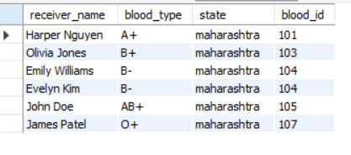

#Calculating the count of donors grouped by blood types:

SELECT bloodtype.blood_type,bloodtype.blood_id, COUNT(donar.donar_id) AS 'Donor_Count'

FROM donar

INNER JOIN bloodtype ON donar.blood_group = bloodtype.blood_type

GROUP BY bloodtype.blood_type;

|  |  |  |
| --- | --- | --- |
| Blood_type | Blood_id | Donate count |
| A+ | 101 | 4 |
| A- | 102 | 4 |
| AB+ | 105 | 4 |
| AB- | 106 | 3 |
| B+ | 103 | 3 |
| B- | 104 | 4 |
| O+ | 107 | 4 |
| O- | 108 | 4 |

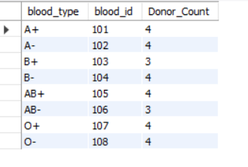

#Finding receivers and their respective blood types in a specific state with a blood type 'A+':

SELECT receiver.receiver_name, receiver.blood_group, receiver.state

FROM receiver

INNER JOIN bloodtype ON receiver.b_id = bloodtype.blood_id

WHERE receiver.state = 'new delhi' AND bloodtype.blood_type = 'A+';

|  |  |  |
| --- | --- | --- |
| Receiver_name | Blood_group | state |
| David Johnson | A+ | new delhi |
| Ethan Davis | A+ | new delhi |

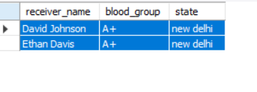

#Fetching donors along with their blood ids:

SELECT donar.donar_name, donar.blood_group AS 'Donor_Blood_Group', bloodtype.blood_id

FROM donar

INNER JOIN bloodtype ON donar.blood_group = bloodtype.blood_type;

|  |  |  |
| --- | --- | --- |
| Donar_name | Donar_bloodgroup | Blood_id |
| Stella Long | A+ | 101 |
| Emily Davis | A+ | 101 |
| Emma White | A+ | 101 |
| Avery Adams | A+ | 101 |
| Jane Smith | A- | 102 |
| Sophia Taylor | A- | 102 |
| Charlotte Martinez | A- | 102 |
| Aria Ward | A- | 102 |
| David Johnson | B+ | 103 |
| Ava Thomas | B+ | 103 |
| Elijah Robinson | B+ | 103 |
| Wyatt Hughes | B- | 104 |
| Olivia Wilson | B- | 104 |
| James Harris | B- | 104 |
| Harper Campbell | B- | 104 |
| Henry Powell | AB+ | 105 |
| sejal bhekare | AB+ | 105 |
| William Miller | AB+ | 105 |
| Mia Martin | AB+ | 105 |
| Sarah Williams | AB- | 106 |
| Noah Anderson | AB- | 106 |
| Lucas Rodriguez | AB- | 106 |
| John Doe | O+ | 107 |
| Ethan Moore | O+ | 107 |
| Benjamin Garcia | O+ | 107 |
| Logan Hill | O+ | 107 |
| Michael Brown | O- | 108 |
| Liam Jackson | O- | 108 |
| Amelia Clark | O- | 108 |
| Grace Sullivan | O- | 108 |

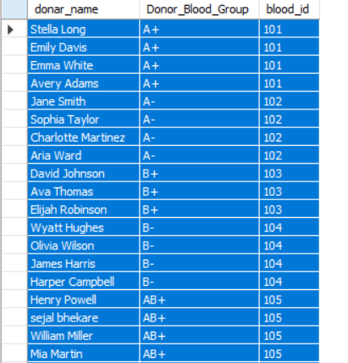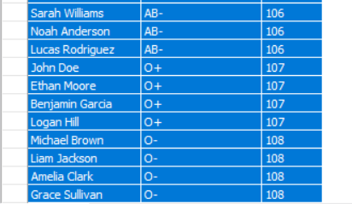

#Finding the count of receivers grouped by their blood groups:

SELECT bloodtype.blood_type, COUNT(receiver.receiver_id) AS 'Receiver_Count'

FROM receiver

INNER JOIN bloodtype ON receiver.b_id = bloodtype.blood_id

GROUP BY bloodtype.blood_type;

|  |  |  |
| --- | --- | --- |
| Blood_type | Blood_id | Received count |
| A+ | 101 | 4 |
| A- | 102 | 3 |
| AB+ | 105 | 5 |
| AB- | 106 | 3 |
| B+ | 103 | 3 |
| B- | 104 | 4 |
| O+ | 107 | 4 |
| O- | 108 | 4 |

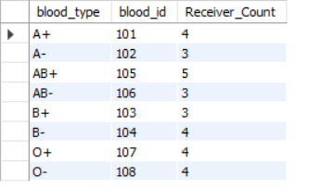

**Sub-queries**

#Retrieve the names of donors who have the same blood type as a specific receiver (e.g., receiver_id = 117).

SELECT *FROM donar WHERE blood_group= (SELECT blood_group FROM receiver WHERE receiver_id = 117);

|  |  |  |  |  |  |  |  |  |  |  |
| --- | --- | --- | --- | --- | --- | --- | --- | --- | --- | --- |
| Donar_id | | Donar_name | gender | age | contactno | Blood group | address | state | Date_of_donate | |
| 105AA | | Henry Powell | Female | 16 | 6767676767 | AB+ | 676 Pine St | rajasthan | 2025-04-04 | |
| 105AD | | sejal bhekare | female | 21 | 7400220393 | AB+ | 228 riva rthyem | maharashtra | 2002-09-28 | |
| 105G | | William Miller | Male | 32 | 1112223334 | AB+ | 808 Walnut St | maharashtra | 2023-07-07 | |
| 105P | | Mia Martin | Female | 23 | 2323232323 | AB+ | 232 PlumSt | uttarpradesh | 2024-04-04 | |
|  |  |  |  |  |  |  |  |  |

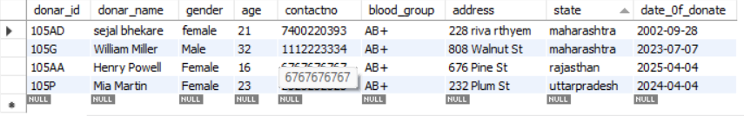

#Find the names of donors who are at least 10 years older than the youngest receiver.

SELECT donar_name, gender, age FROM donar

WHERE age> (SELECT MIN(age) + 10 FROM receiver);

|  |  |  |
| --- | --- | --- |
| Donar_name | gender | age |
| Stella Long | Male | 43 |
| Aria Ward | Male | 41 |
| David Johnson | Male | 40 |
| Elijah Robinson | Male | 38 |
| James Harris | Male | 36 |
| Harper Campbell | Male | 40 |
| William Miller | Male | 32 |
| Sarah Williams | Female | 35 |
| Noah Anderson | Male | 33 |
| Lucas Rodriguez | Male | 39 |
| Ethan Moore | Male | 31 |
| Benjamin Garcia | Male | 37 |
| Grace Sullivan | Male | 42 |

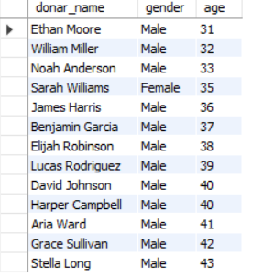

#Retrieve the count of male and female donors.

SELECT gender, COUNT(*) AS count_gender FROM donar

GROUP BY gender;

|  |  |
| --- | --- |
| gender | Donate count |
| Female | 15 |
| Male | 15 |

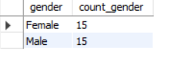

#List the donors who donated blood after the year 2023 in descending order of their ages.

SELECT donar_name, age, date_0f_donate FROM donar

WHERE YEAR(date_0f_donate) > 2023 ORDER BY age DESC;

|  |  |  |
| --- | --- | --- |
| Donar name | Age | Date of donate |
| Stella Long | 43 | 2025-05-05 |
| Grace Sullivan | 42 | 2025-03-03 |
| Aria Ward | 41 | 2025-01-01 |
| Harper Campbell | 40 | 2024-11-11 |
| Lucas Rodriguez | 39 | 2024-09-09 |
| Elijah Robinson | 38 | 2024-07-07 |
| Benjamin Garcia | 37 | 2024-05-05 |
| James Harris | 36 | 2024-03-03 |
| Emma White | 30 | 2024-02-02 |
| Liam Jackson | 24 | 2024-01-01 |
| Mia Martin | 23 | 2024-04-04 |
| Charlotte Martinez | 21 | 2024-06-06 |
| Amelia Clark | 20 | 2024-08-08 |
| Avery Adams | 19 | 2024-10-10 |
| Logan Hill | 18 | 2024-12-12 |
| Henry Powell | 16 | 2025-04-04 |
| Wyatt Hughes | 15 | 2025-06-06 |

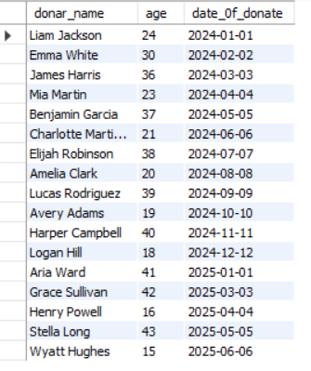

**THE CONCLUSION OF A PROJECT** on blood bank database management encapsulates the achievements, outcomes, and implications of the implemented system.

"In conclusion, the development and implementation of the Blood Bank Database Management System have significantly improved the efficiency, reliability, and accessibility of vital information within our blood bank facility. Through meticulous planning and execution, the system has successfully addressed numerous challenges associated with blood inventory management, donor-recipients matching, and overall operational streamlining.

One of the primary accomplishments of this project is the establishment of a centralized and secure database that houses comprehensive information about donors, recipients, and blood inventory. This has facilitated quick and accurate matching of donors and recipients, ensuring timely access to compatible blood types and improving the overall response time in emergency situations.

The system's user-friendly interface has played a pivotal role in encouraging regular blood donations by providing donors with a convenient platform to schedule appointments, receive reminders, and track their donation history. Additionally, the implementation of security measures ensures compliance with data privacy regulations while safeguarding sensitive donor and patient information.

The successful integration of this system with existing healthcare infrastructure and its scalability features have positioned our blood bank for future growth and seamless collaboration with external stakeholders.

Overall, the Blood Bank Database Management System has significantly enhanced our ability to serve the community by ensuring a consistent and ample supply of blood, thereby contributing to the lifesaving mission of our organization. Moving forward, continued maintenance, periodic updates, and ongoing staff training will be crucial to sustaining the effectiveness and relevance of this system in meeting the evolving needs of our blood bank and the beneficiaries it serves."

Top of Form

**THANK YOU**

